- BUSINESS CARD

package tz.ac.suza.exercise.lab2
import android.os.Bundle
import androidx.activity.ComponentActivity
import androidx.activity.compose.setContent
import androidx.compose.foundation.background
import androidx.compose.foundation.layout.*
import androidx.compose.foundation.shape.CircleShape
import androidx.compose.material3.*
import androidx.compose.runtime.Composable
import androidx.compose.ui.Alignment
import androidx.compose.ui.Modifier
import androidx.compose.ui.draw.clip
import androidx.compose.ui.graphics.Color
import androidx.compose.ui.text.font.FontWeight
import androidx.compose.ui.unit.dp
import androidx.compose.ui.unit.sp
class MainActivity : ComponentActivity() {
override fun onCreate(savedInstanceState: Bundle?) {
super.onCreate(savedInstanceState)
setContent {
BusinessCard()
}
}
}
@Composable
fun BusinessCard() {
Column(
modifier = Modifier
.fillMaxSize()
.padding(20.dp),
horizontalAlignment = Alignment.CenterHorizontally,
verticalArrangement = Arrangement.Center
) {
Box(
modifier = Modifier
.size(120.dp)
.clip(CircleShape)
.background(Color.Gray)
)
Spacer(modifier = Modifier.height(20.dp))
Text(
text = "Khudhaima Mshamba",
fontSize = 28.sp,
fontWeight = FontWeight.Bold
)
Text(
text = "Mobile Application Developer",
color = Color.Gray,
fontSize = 18.sp
)
Text(
text = "Business Card",
color = Color.Gray,
fontSize = 16.sp
)
Spacer(modifier = Modifier.height(20.dp))
Row(
verticalAlignment = Alignment.CenterVertically
) {
Spacer(modifier = Modifier.width(10.dp))
Text(text = "khudhaimamshamba@gmail.com")
}
Spacer(modifier = Modifier.height(10.dp))
Row(
verticalAlignment = Alignment.CenterVertically
) {
Spacer(modifier = Modifier.width(10.dp))
Text(text = "0613281151")
}
Spacer(modifier = Modifier.height(10.dp))
Row(
verticalAlignment = Alignment.CenterVertically
) {
Spacer(modifier = Modifier.width(10.dp))
Text(text = "linkedin.com/khudhaima")
}
}
}

OUTPUT
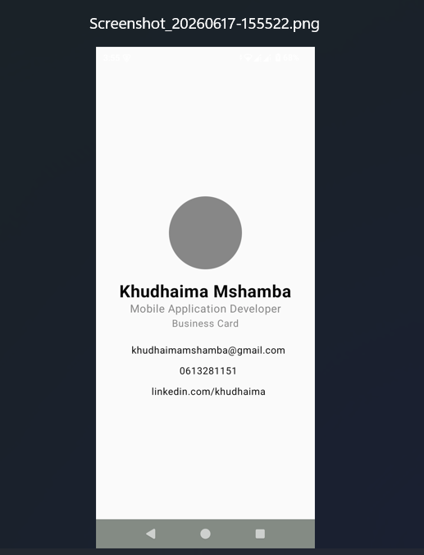
- GREETING CARD
- package tz.ac.suza.exercise.lab2
import androidx.compose.foundation.Image
import androidx.compose.foundation.layout.Arrangement
import androidx.compose.foundation.layout.Column
import androidx.compose.foundation.layout.fillMaxSize
import androidx.compose.foundation.layout.padding
import androidx.compose.material3.MaterialTheme
import androidx.compose.material3.Text
import androidx.compose.runtime.Composable
import androidx.compose.ui.Alignment
import androidx.compose.ui.Modifier
import androidx.compose.ui.graphics.Color
import androidx.compose.ui.res.painterResource
import androidx.compose.ui.text.font.FontFamily
import androidx.compose.ui.text.font.FontWeight
import androidx.compose.ui.unit.dp
import androidx.compose.ui.unit.sp
import tz.ac.suza.lab2.R
@Composable
fun GreetingCard() {
Column(
modifier = Modifier.fillMaxSize(),
verticalArrangement = Arrangement.Center,
horizontalAlignment = Alignment.CenterHorizontally
) {
Image(painter =painterResource(id=R.drawable.ic_launcher_background ), contentDescription = null
)
Text(
text = "Welcome To Suza",
fontFamily = FontFamily.SansSerif,
fontWeight= FontWeight.Bold,
fontSize = 35.sp,
style = MaterialTheme.typography.bodyLarge,
modifier = Modifier.padding(vertical = 12.dp)
)
Text(
text ="Mobile Development",
color= Color.Gray,
fontSize = 20.sp,
style = MaterialTheme.typography.labelLarge
)
Text(
text = "Greeting Card",
color = Color.Gray,
fontSize = 18.sp,
)
}
}
OUTPUT
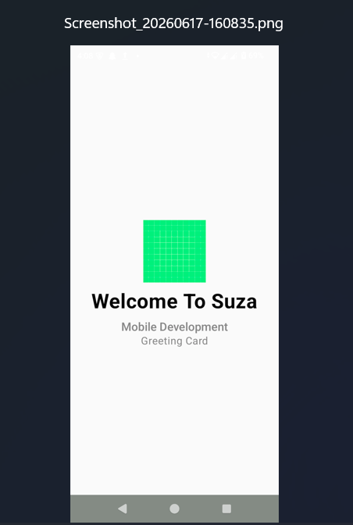
- FOUR QUADRANT LAYOUT
- package tz.ac.suza.exercise.lab2
import androidx.compose.foundation.layout.*
import androidx.compose.material3.Surface
import androidx.compose.material3.Text
import androidx.compose.runtime.Composable
import androidx.compose.ui.Alignment
import androidx.compose.ui.Modifier
import androidx.compose.ui.graphics.Color
import androidx.compose.ui.text.font.FontWeight
import androidx.compose.ui.text.style.TextAlign
import androidx.compose.ui.unit.dp
@Composable
fun FourQuadrantLayout() {
Column(
modifier = Modifier.fillMaxSize()
) {
Row(
modifier = Modifier.weight(1f)
) {
QuadrantCard(
title = "Text composable",
description = "Displays text and follows Material Design guidelines.",
backgroundColor = Color.Green,
modifier = Modifier.weight(1f)
)
QuadrantCard(
title = "Image composable",
description = "Creates a composable that lays out and draws an image.",
backgroundColor = Color.Yellow,
modifier = Modifier.weight(1f)
)
}
Row(
modifier = Modifier.weight(1f)
) {
QuadrantCard(
title = "Row composable",
description = "A layout composable that places children in a horizontal sequence.",
backgroundColor = Color.Cyan,
modifier = Modifier.weight(1f)
)
QuadrantCard(
title = "Column composable",
description = "A layout composable that places children in a vertical sequence.",
backgroundColor = Color.LightGray,
modifier = Modifier.weight(1f)
)
}
}
}
@Composable
fun QuadrantCard(
title: String,
description: String,
backgroundColor: Color,
modifier: Modifier = Modifier
) {
Surface(
color = backgroundColor,
modifier = modifier.fillMaxSize()
) {
Column(
modifier = Modifier
.padding(16.dp)
.fillMaxSize(),
verticalArrangement = Arrangement.Center,
horizontalAlignment = Alignment.CenterHorizontally
) {
Text(
text = title,
fontWeight = FontWeight.Bold
)
Spacer(modifier = Modifier.height(16.dp))
Text(
text = description,
textAlign = TextAlign.Center
)
}
}
}
OUTPUT
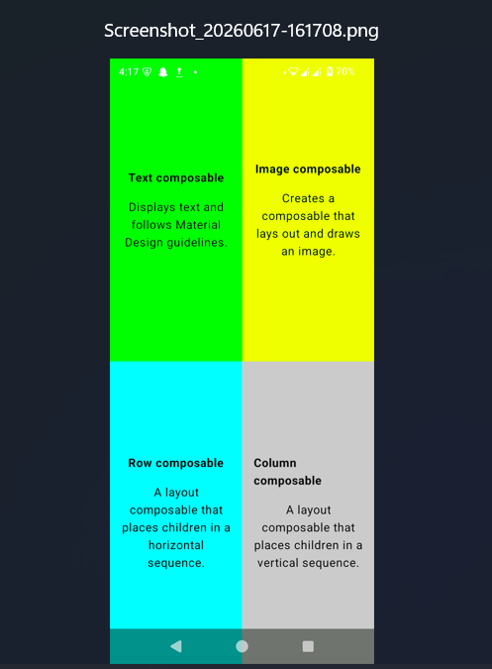
- TASK CARD
- package tz.ac.suza.exercise.lab2
import androidx.compose.foundation.background
import androidx.compose.foundation.layout.*
import androidx.compose.material3.Card
import androidx.compose.material3.Text
import androidx.compose.runtime.Composable
import androidx.compose.ui.Modifier
import androidx.compose.ui.graphics.Color
import androidx.compose.ui.text.font.FontWeight
import androidx.compose.ui.tooling.preview.Preview
import androidx.compose.ui.unit.dp
@Composable
fun TaskCard(
title: String,
description: String,
priority: String
) {
val borderColor = when(priority) {
"High" -> Color.Red
"Medium" -> Color(0xFFFF9800)
else -> Color.Green
}
Card(
modifier = Modifier
.fillMaxWidth()
.padding(8.dp)
) {
Row {
Box(
modifier = Modifier
.width(8.dp)
.height(100.dp)
.background(borderColor)
)
Column(
modifier = Modifier.padding(16.dp)
) {
Text(
text = title,
fontWeight = FontWeight.Bold
)
Spacer(modifier = Modifier.height(8.dp))
Text(text = description)
Spacer(modifier = Modifier.height(8.dp))
Text(text = priority)
}
}
}
}
@Preview(showBackground = true)
@Composable
fun TaskCardPreview() {
Column {
TaskCard(
"Finish Assignment",
"Complete Compose lab exercises",
"High"
)
TaskCard(
"Read Notes",
"Study Jetpack Compose basics",
"Medium"
)
TaskCard(
"Practice",
"Build small Compose apps",
"Low"
)
}
}
OUTPUT
